OS Assignment 1

Meenakshi Madhu

B180390CS – Group 04

## Part 1

Qn. Download the latest stable Linux kernel from kernel.org, compile it and dual boot it with your current Linux version. Your current version as well as the new version should be present in the grub-menu.

Steps:

1. $ wget https://cdn.kernel.org/pub/linux/kernel/v5.x/linux-5.8.14.tar.xz

Command used to download Linux kernel source code.

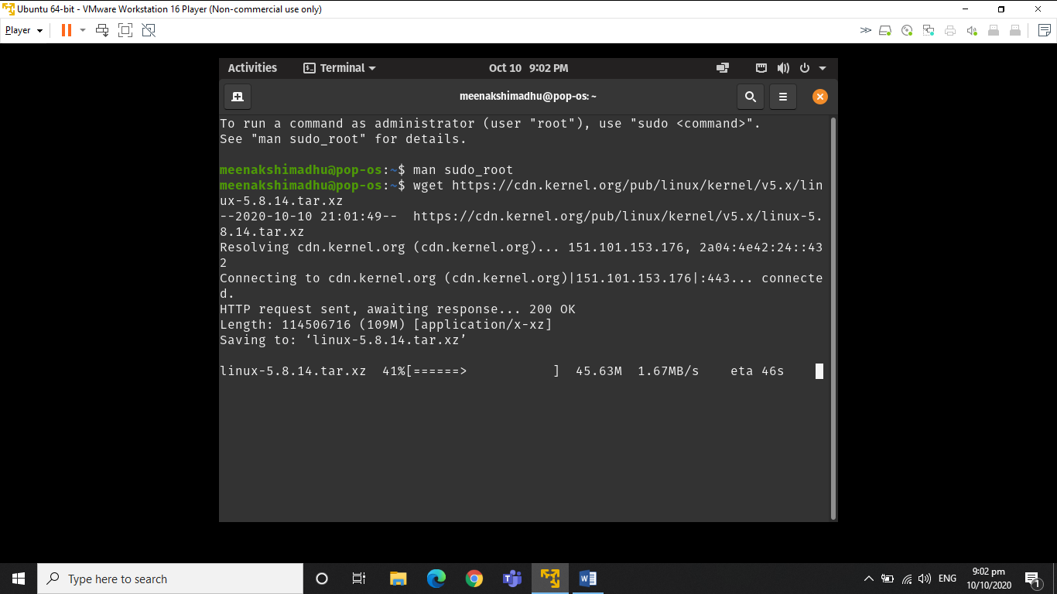

2. $ unxz -v linux-5.8.14.tar.xz

Command for extracting the tar.xz file.

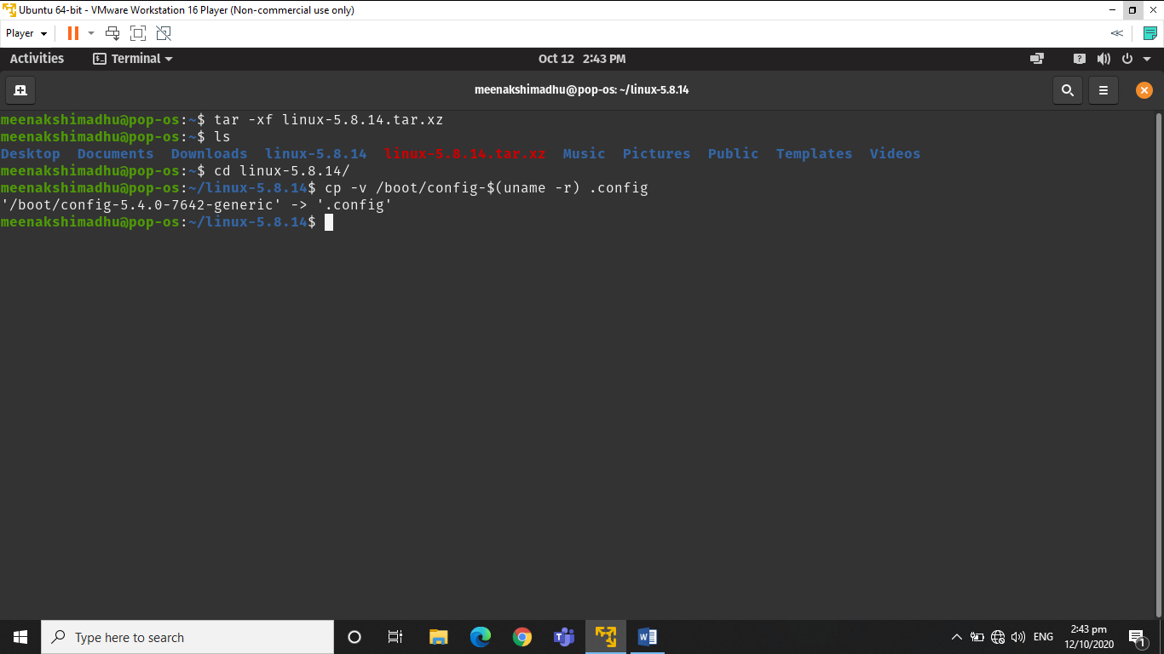

3. $ cd linux-5.6.9

Change directory to the unzipped folder.



4. $ cp -v /boot/config-$(uname -r) .config

Command to configure the Linux kernel features.

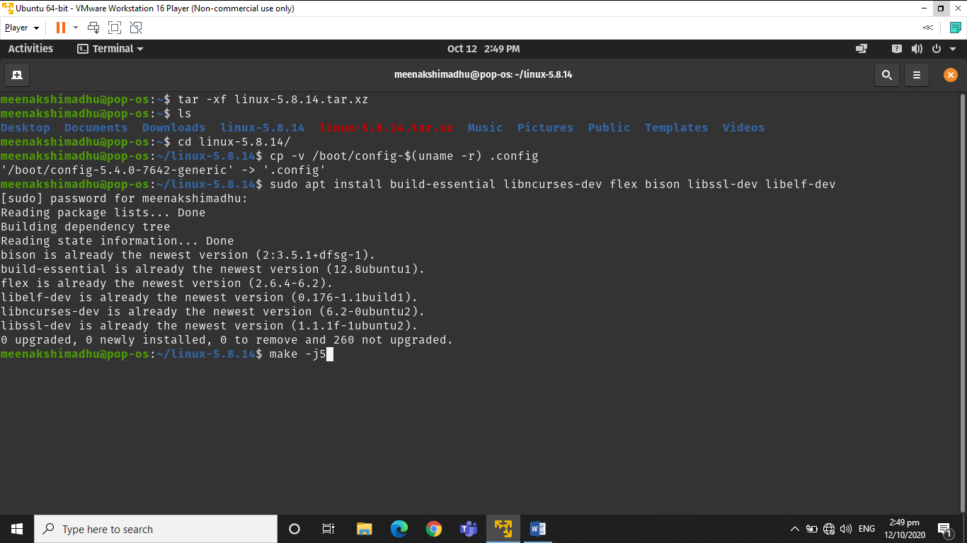

5. $ sudo apt-get install build-essential libncurses-dev bison flex libssl-dev libelf-dev

Command to install development tools like GCC compilers and related tools, to compile the Linux kernel.



6. $ make menuconfig

Command to configure the kernel. Can be used to enable or disable certain features or modules.

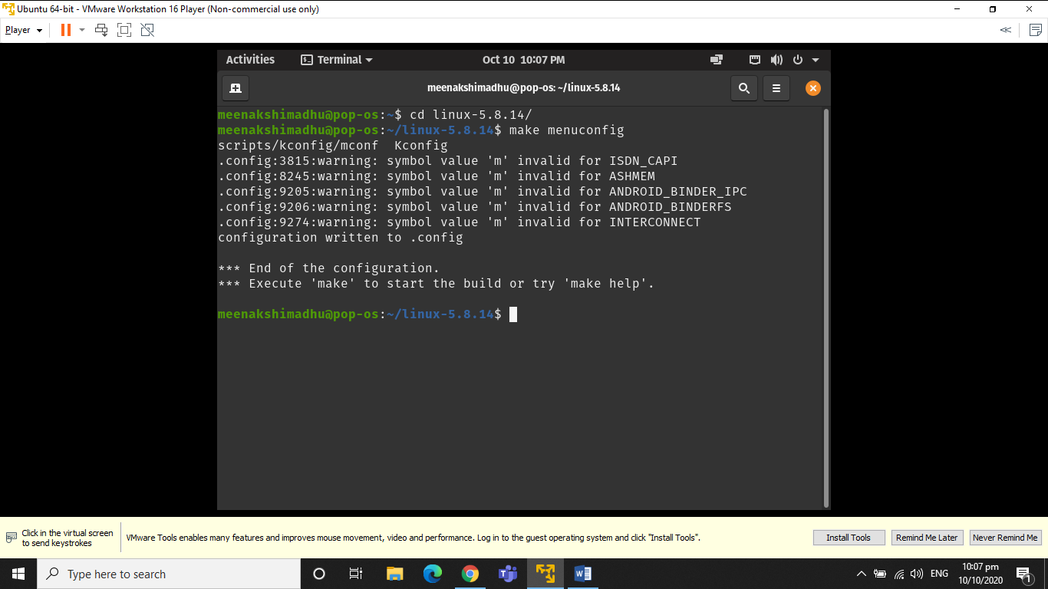

7. $ make -j5

Make command is used to compile and create a compressed kernel image. -j5 is passed to speed up the compile time. Build time depends on the system's resources such as available CPU core and current system load.



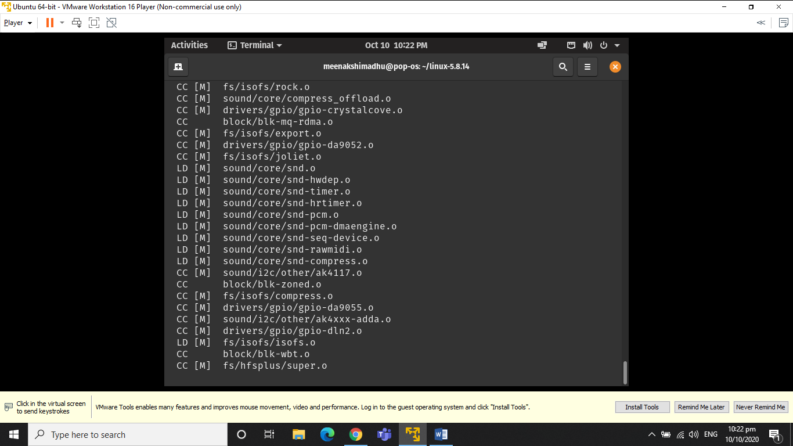

8. $ sudo make modules_install

Command to install Linux kernel modules.

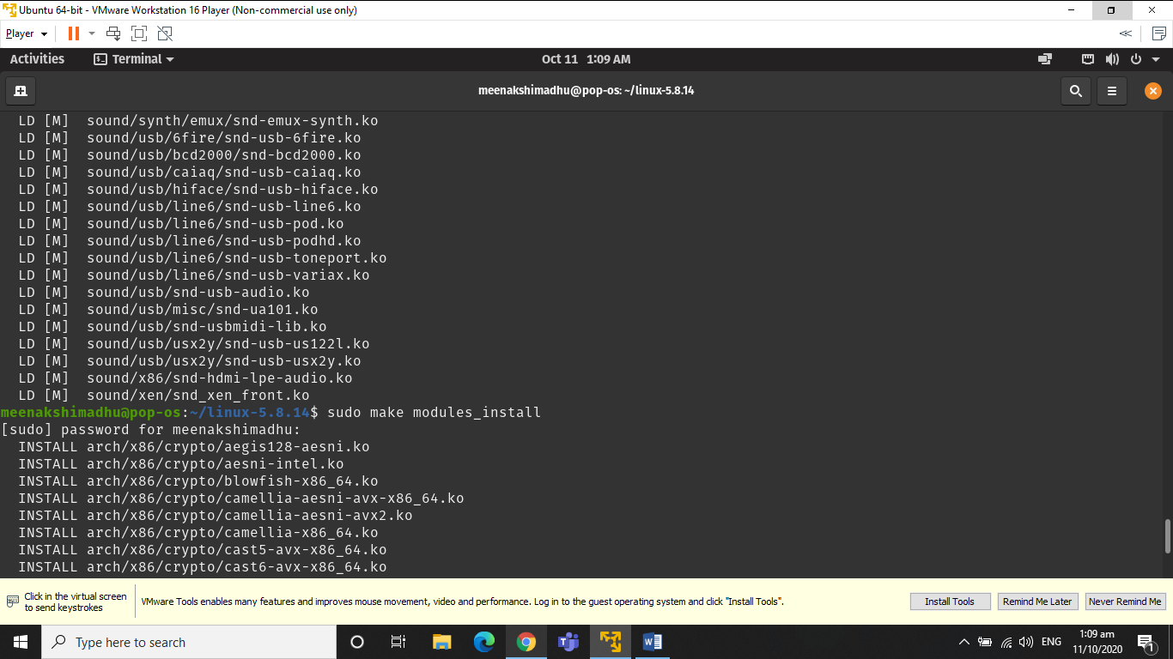

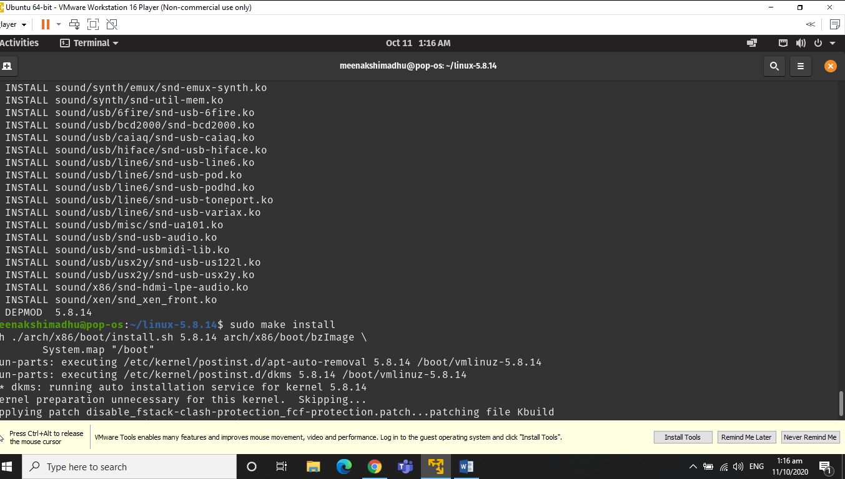

9. $ sudo make install

Command to install the kernel.

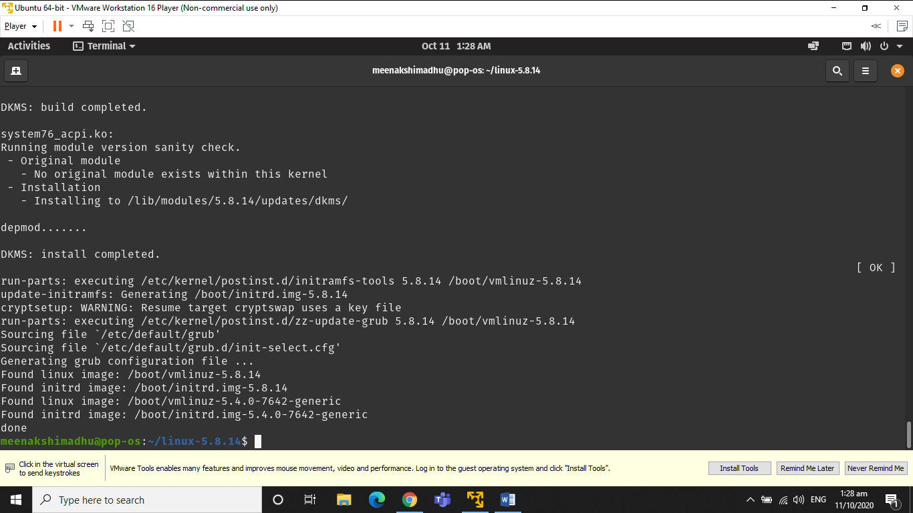

On reboot, the newly installed kernel can be seen in the grub-menu:

